***Group 10***

***Project Members:***

*1.Rithwik sai.P*

*2.Likhith Reddy.K*

*3.Hari Chandan.K*

***Assumption:***

*Sometimes in order to reduce cost company removes employees but that won’t solve the problem every time because without following the patterns or getting incorrect insights may push the company into further problems*

***Motivation:-***

*AS THE COVID-19 KEEPS UNLEASHING ITS HAVOC, THE WORLD CONTINUES TO GET PUSHED INTO THE CRISIS OF THE GREAT ECONOMIC RECESSION, MORE AND MORE COMPANIES START TO CUT DOWN THEIR UNDERPERFORMING EMPLOYEES. COMPANIES FIRING HUNDREDS AND THOUSANDS OF EMPLOYEES IS A TYPICAL HEADLINE TODAY. CUTTING DOWN EMPLOYEES OR REDUCING AN EMPLOYEE SALARY IS A TOUGH DECISION TO TAKE. HERE IN THIS PROJECT WE LOOK AT VARIOUS PARAMETERS RESPONSIBLE FOR ATTRITION OF EMPLOYEE AND AT THE END WILL BUILD A MODEL TO PREDICT EMPLOYEE ATTRITION.*

***Benefits of the solution:***

*Consider the program is a success, it would directly boost the company overall performance. It doesn’t only help the companies’ performance but also helps the employees who are worth and deserved.*

***Technologies Used:***

1. *SQL*
2. *Python*
3. *Machine Learning*
4. *Data Science*
5. *Statistics*

*So what is the need of Feature Selection?*

*\* It enables the machine learning algorithm to train faster.*

*\* It reduces the complexity of a model and makes it easier to interpret.*

*\* It improves the accuracy of a model if the right subset is chosen*

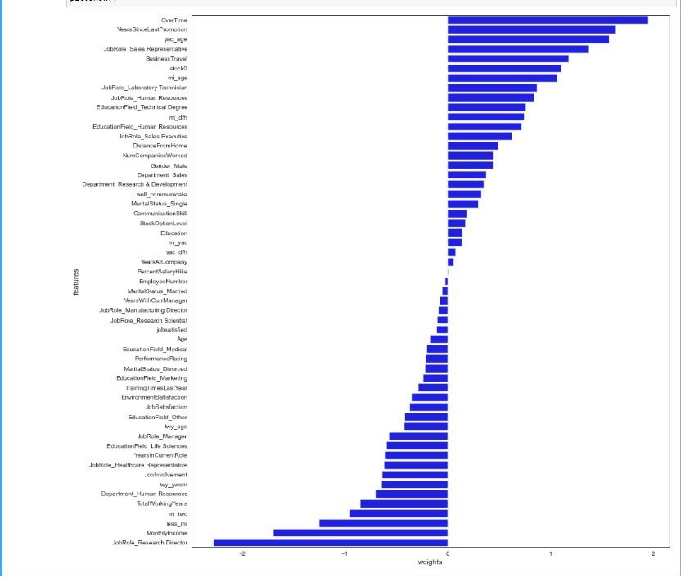

*DATA VISUALIZATION:*

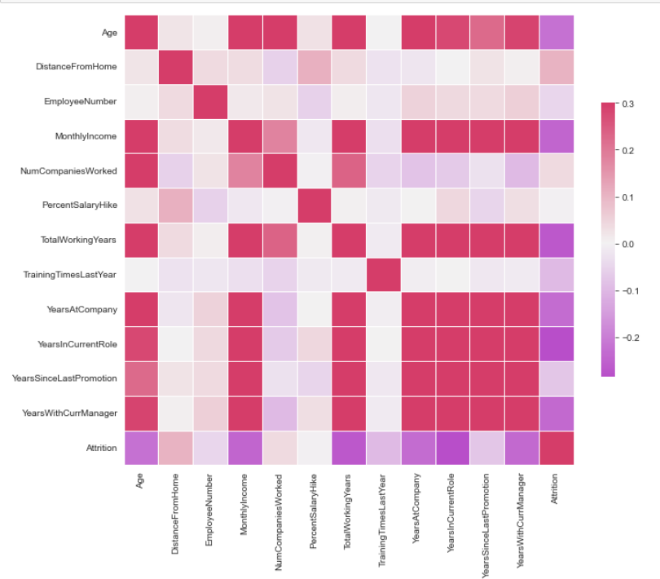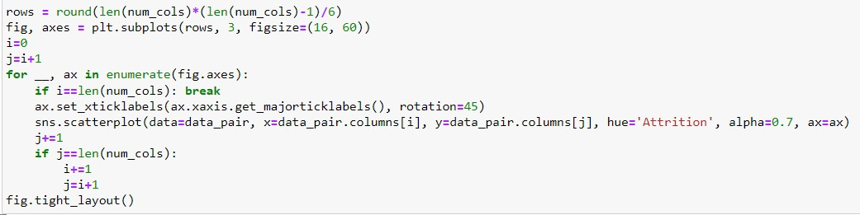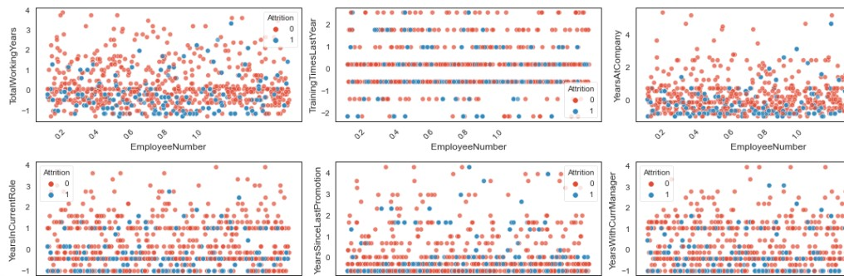

*USECASE DIAGRAM:*

*An Entity-Relationship (ER) diagram is used to model the relationships between different entities in a system. For an employee attrition machine learning project, the entities involved might include employees, departments, managers, and other relevant factors. Here is an example ER diagram:*

*The "Attrition (ML)" entity is related to the "Employee" entity through the "Employee_ID" attribute, and to the "Factor" entity through the "Factors" attribute. The "Attrition (ML)" entity also has a "Probability" attribute, which represents the predicted probability of an employee leaving the company.*

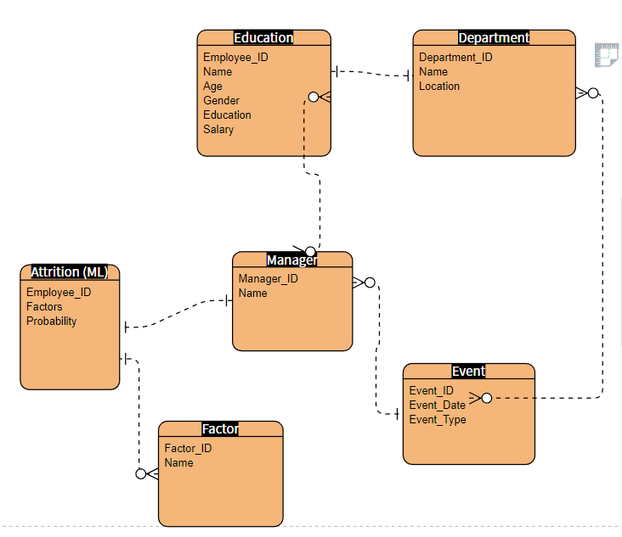

*In this diagram, the "Employee" entity represents individual employees, each of whom has a unique ID, name, age, gender, education, salary, and other attributes. The "Department" entity represents different departments in the company, with a unique department ID, name, and location.*

*The "Manager" entity represents the managers of each department, with a unique manager ID and name. The "Factor" entity represents the various factors that could contribute to employee attrition, such as job satisfaction, workload, career growth opportunities, etc.*

*The "Event" entity represents any events that could impact employee attrition, such as a change in job role or a promotion. Finally, the "Attrition (ML)" entity represents the machine learning model that predicts the probability of an employee leaving the company based on various factors.*

*The "Attrition (ML)" entity is related to the "Employee" entity through the "Employee_ID" attribute, and to the "Factor" entity through the "Factors" attribute. The "Attrition (ML)" entity also has a "Probability" attribute, which represents the predicted probability of an employee leaving the company*

*End*